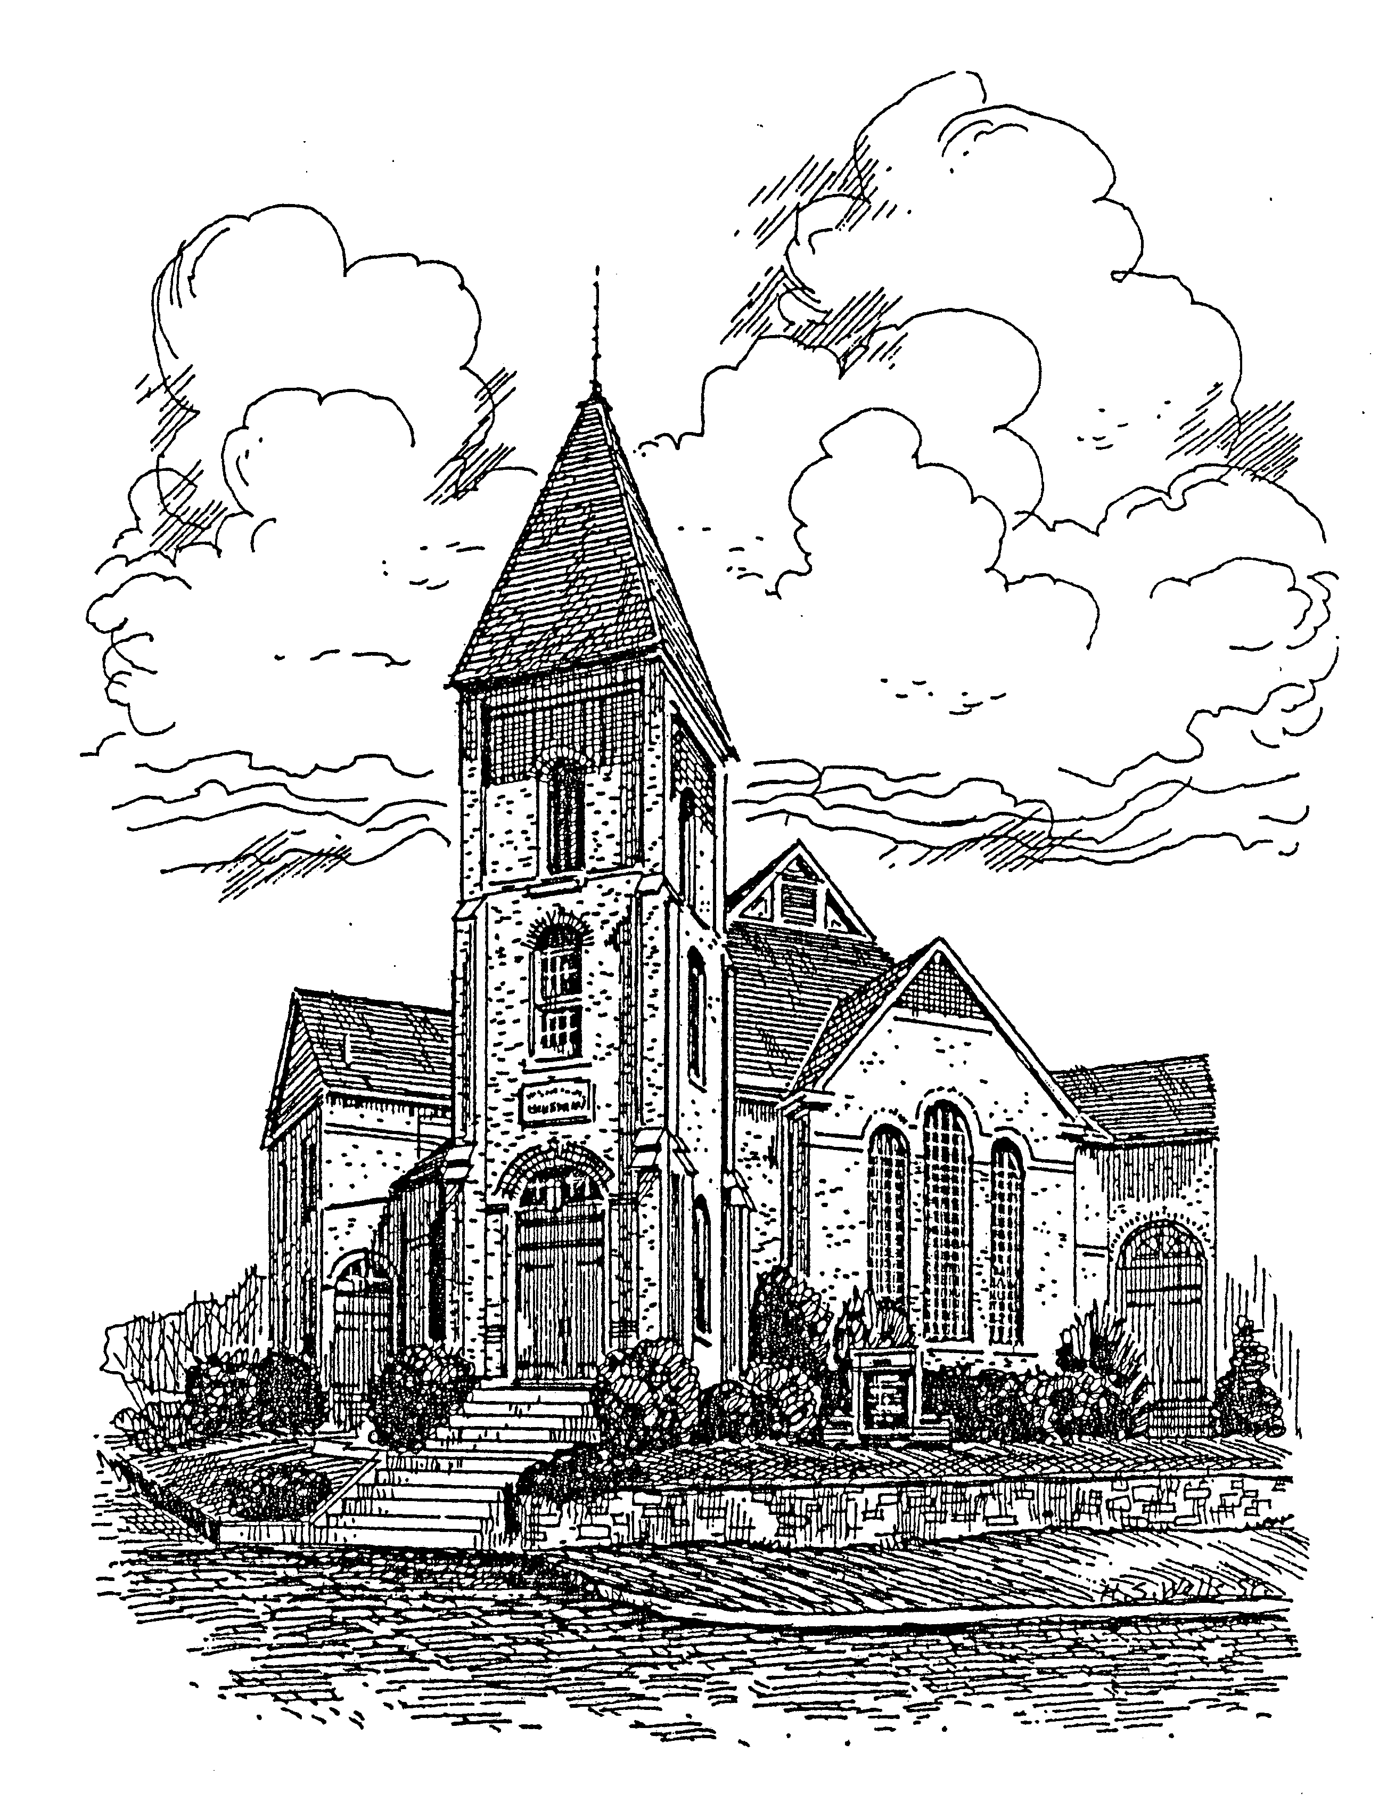

CELEBRATION OF WORSHIP
SECOND SUNDAY OF CHRISTMAS
January 5, 2025

FIRST PRESBYTERIAN CHURCH
225 Church Street, Jackson, Ohio 45640
Phone (740) 286-1928
Fax (740) 286-1730
E-mail: firstpres3@frontier.com
Facebook: First Presbyterian Church of Jackson Ohio
Website: http://www.firstpresbyterianofjackson.org/
Coffee Hour 10:00 a.m.

Sunday Morning Worship: 10:30 a.m.

FIRST PRESBYTERIAN CHURCH

Jackson, Ohio
Second Sunday of Christmas
January 5, 2025
10:30 a.m.

Order of Worship

ORGAN PRELUDE “Angels We Have Heard on High”, arr. by Warner

INTROIT

WELCOME

CALL TO WORSHIP
The Word became flesh and dwelt among us,
full of grace and truth.
We have beheld his glory.
Alleluia!

PRAYER OF THE DAY
Almighty God,
you have filled us with the light of the Word
who became flesh and lived among us.
Let the light of faith shine in all that we do;
through Jesus Christ our Lord,
who lives and reigns with you in the unity of the Holy Spirit,
one God,
now and forever.
Amen.

*HYMN #145 “What Child Is This”

PRAYER OF CONFESSION
God of grace and truth,
in Jesus Christ,
you came among us as light shining in darkness.
We confess that we have not welcomed the light,
or trusted Good News to be good.
We have closed our eyes to glory in our midst,
expecting little,
and hoping for less.
Forgive our doubt,
and renew our hope,
so that we may receive the fullness of your grace,
and live in the Truth of Christ the Lord. Amen.

ASSURANCE OF PARDON
Hear the Good News!
If anyone is in Christ, that one becomes a new person altogether—
The past is finished and gone,
Everything has become fresh and new.
Friends,
Believe the Good News of the Gospel:
In Jesus Christ,
Amen.

THE PASSING OF THE PEACE

SCRIPTURE READINGS
OT: Ephesians 1:3-14

ANTHEM “The Memory of Christmas”

G: John 1:1-18

Response to the Reading of Scripture
The Word of God for the People of God.
Thanks be to God!

SERMON:

*HYMN #108 “Of the Father’s Love Begotten” verses 1-2 & 5-6

*AFFIRMATION OF FAITH: THE APOSTLES’ CREED
I believe in God the Father almighty,
maker of heaven and earth.

And in Jesus Christ his only Son our Lord;
who was conceived by the Holy Ghost,
born of the Virgin Mary,
suffered under Pontius Pilate,
was crucified, dead, and buried;
he descended into Hell;
the third day he rose again from the dead;
he ascended into Heaven,
and sitteth on the right hand of God the Father almighty;
from thence he shall come to judge the quick and the dead.

I believe in the Holy Ghost;
the Holy Catholic Church;
the communion of Saints;
the forgiveness of sins,
the resurrection of the body;
and the life everlasting. Amen.

PRAYERS OF THE PEOPLE
Joys and Concerns
Pastoral Prayer and Silent Prayer
The Lord’s Prayer
“Forgive us our debts, as we forgive our debtors.”

PRESENTATION OF TITHES AND OFFERINGS
Offertory
*Doxology HYMN #606
*Prayer of Consecration
Blessed are you, God of all creation;
through your goodness we have these gifts to share.
Accept and use our offering for your glory and for the service of your kingdom.
Blessed be God forever.
Amen.

*HYMN #119 “Hark! The Herald Angels Sing”

BENEDICTION

POSTLUDE “We Three Kings”, arr. by Young

(*The congregation is invited to stand.)

ANNOUNCEMENTS
Today
Happy New Year!
--Loose Change Sunday – to assist the Deacons
-- Offering Envelopes for 2025 are available today - located in the Builders’ Room.

Monday, January 6, 2025
--1:00 p.m. Woman’s Literary Club meeting in Fellowship Hall.

Tuesday, January 7, 2025
10:00 a.m. Bible Study resumes. Plan to join us!

Wednesday, January 8, 2025
--11:30 a.m. The Traveling Diners will meet at Casa Grande for lunch. Join us!

Thursday, January 9, 2025
--Annual Reports are due in the church office.
-- 6:30 p.m. Choir Rehearsal

Next Sunday, January 12, 2025
--Ordination/Installation of officers during the worship service.

DONATED FOOD ITEMS NEEDED FOR BLESSING BOX
Please donate nonperishable food items to the church if you are able. We would like to have several food items available here at the church so we can keep the blessing box supplied. Thank you for your help with this much needed mission. (Place in wooden food collection box located just inside the door.)

OUR PRAYER LIST: If you wish to add people to the printed prayer list below, please put your request in writing and give it to the pastor before the worship service, or put it in the offering plate, or e-mail it to firstpres3@frontier.com.

Please be faithful to keep these people in your thoughts and prayers throughout the week: Barb Crusan, Steve Brown, Vicki Williams, Jeff Ridgeway, Rhea Shupe, Shirley Anderson, Sigrid Sheward, Charlie Johnson, Donna Hogue, Patti Reynolds, Betty Richards, Becky Crusan, Phil Arbaugh, Kim Folden, Chuck Harley, Rick Holt, Thomas Boggs – US Army, Hayden Boggs – US Army

Note: Please call the church office 740-286-1928 to update this list.

Pastor………………………………………………Rev. John E. Birkner
Administrative Assistant…………………………..Mrs. Melody Morgan
Organist………………………………........Mrs. Mary Elizabeth Billman
Music Director……………………………………………Mr. Paul Hogue
Ushers…………………………………………………………Greg Ervin
Attendance last Sunday……………………………………………….32

Church Office Hours: Tues., Wed., Thurs. 9:00 a.m. – 3:00 p.m.
Melody’s cell #: 740-418-0754 email: melody401@frontier.com

Pastor John Birkner’s contact information:
E-mail: johnbirkner@yahoo.com
Church Office: 740-286-1928
Cell Phone: 614-421-8289 Home Phone: 614-237-2275

--ANNUAL CONGREGATIONAL MEETING to review annual reports will be held Sunday, January 19, 2025 following worship and lunch in Fellowship Hall. Please plan to be present.

